Inferential Statistics.
Continuing work from class..
We have already introduced the idea of confidence intervals for population means
A confidence interval of 95% that the value lies within the parameter is:
$$\overline{x}-1.96\frac{}{\sqrt{n}}≤≤\overline{x}+1.96\frac{}{\sqrt{n}}$$
Where $1.96\frac{}{\sqrt{n}}=margin or error$ for population mean at 95% confidence level
$\overline{x}=mean$ of sample
σ = population standard deviation
n= amount in sample
μ= population mean

Question:
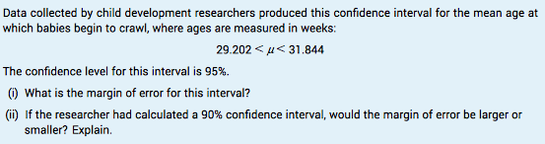

Sample Proportion
$$\hat{p}=sample proportion.$$
$$p=population proportion$$

To understand what the p hat symbol represents and how it is used, the difference between a population and a sample must first be understood. In the study of statistics, the word "population" refers to the entire group that is being studied. A "sample," on the other hand, is only a part of that group. A sample is, ideally, representative of the entire group, meaning that a statistician can study the habits, behaviours and characteristics of that small group and then generalize the findings to the entire population. In statistics, a lower-case p without a caret above it stands for "population proportion." When a statistician calculates the population proportion, the entire group is being factored into the equation.
However, the p hat symbol is used to refer to an even smaller group: a proportion of the sample of the entire group. The p hat is often used when discussing the results of surveys. For example, a statistician asks a sample group of 500 adults if they like grape soda; 342 say yes, 100 say no and 58 have no opinion. The statistician is interested in which proportion like grape soda, so an equation will be formulated to find the p hat, or the proportion that answered "yes." The p hat will then be expressed as a percentage or a fraction of the sample group.

$$\hat{p}=\frac{x}{n}$$

$x=number of successes in sample n$
$$n=size of sample$$
So in the above example $\hat{p}=\frac{342}{500}$
$$\hat{p} may vary from sample to sample ( see example in book page 152)$$
this is called sampling variability
If it were possible to collect every sample of size 1000, the distribution of the sample proportions would be normal. The mean of the distributions would be $p$ and the standard deviation would be:

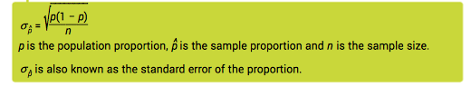

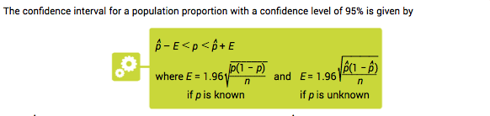

Questions:
Page 155 Questions 8 and 9.

Hypothesis Testing
A Hypothesis is a claim/statement about a population.
We use an hypothesis test to test this claim/statement.

Example:
70% of car crashes involve adults under 25.

Null Hypothesis ($H_{0})$
The statement being tested in a test of significance is called The null hypothesis.

Alternative Hypothesis ($H_{A} or H_{1})$
This is a statement that the population parameter has a value different from what is assumed under the null hypothesis.

When testing hypothesis we set up a confidence interval for the population proportion at a given confidence level.
- If the null hypothesis is outside the confidence interval we reject the null hypothesis in favour of the alternative hypothesis.
- If the null hypothesis is inside the confidence interval we fail to reject the null hypothesis ( never say accept null hypothesis)

How to Answer Hypothesis test Questions.
- Write down ands state $H_{0 } and H_{1}$
- Write down or calculate $\hat{p}$ or $\overline{x}$ (depends on test statistic in question)
- If $\hat{p}$ set up confidence interval at 5% significance (95% confidence level),(see above)
If $\overline{x} convert to z-score$if $\left|z\right|<1.96then fail to reject null hypothesis$if it is greater than or equal to 1.96 or less than or equal to 1.96 we reject the null hypothesis.

To see worked examples check examples in book page 158 and page 159.
Its important to recognise if you all dealing with $\hat{p}$ or $\overline{x}$.

P value.
The p-value is the probability of getting a z score equal to or greater than the positive value of the z value in question and less than or equal to the negative z-value in question. If it the result is less than a significant level of 5% (0.05) then we reject the null hypothesis.
See example 5.13 page 158/9

Questions pg 158-159 questions 1-5 Revsision Questions: Page160/1 Q2,4,6,8,10

We will go through exam question when we get back to class. We will also have an exam.
Attempt all questions.
If you have any questions send them to stjohnsdelasalle@live.ie

